Maximum Power Transfer and Thevenin's Theorem
Avery Izatt
EECE 225L
Instructor: Dr Michelle Mellenthin
September 30, 2026

Abstract
This report investigates maximum power transfer and verified Thevenin's theorem using two resistor circuits. For the maximum power transfer experiment, a 5 V source with a 100 Ω nominal internal resistance was tested with six load resistors. Measured load voltage and current were used to calculate power, and MATLAB curves were used to compare measured behavior with theory. The theoretical maximum was 62.5 mW at a 100 Ω load, while the closest tested load, 266.7 Ω, produced the greatest measured power of 46.8 mW. For the Thevenin experiment, the calculated values were 10.31 V and 1.1575 kΩ. Measured values were 10.3504 V and 1.14087 kΩ. With a 3.3 kΩ load, the original circuit produced 7.688 V and the constructed Thevenin equivalent produced 7.7015 V. The close agreement confirmed both the maximum power transfer relationship and the validity of the Thevenin equivalent.

Introduction
The purpose of this laboratory was to examine the relationship between source resistance, load resistance, load power, and efficiency, and to verify that a linear circuit can be replaced by an equivalent Thevenin source. Experiment 8 focused on maximum power transfer, while Experiment 13 focused on calculating, measuring, and constructing a Thevenin equivalent circuit [1].
For a Thevenin source, the external circuit can be represented by a voltage source VTH in series with an equivalent resistance RTH. Maximum load power occurs when the load resistance RL equals RTH. At this condition, the source resistance and load resistance dissipate equal power, so power transfer efficiency is 50 percent. Increasing RL above RTH raises efficiency but decreases load power.
The report presents the experimental methods, measured data, MATLAB power and efficiency plots, comparison of calculated and measured Thevenin values, responses to the laboratory questions, and conclusions from both experiments.

Methods
Experiment 8 used a GW Instek GPP 3323 direct current power supply adjusted to 5 V, a nominal 100 Ω resistor to represent source internal resistance, a Mastech MS8217 digital multimeter, and six interchangeable load resistors. The 100 Ω resistor measured 98.67 Ω. The nominal load values of 270 Ω, 470 Ω, 1 kΩ, 2.2 kΩ, 4.7 kΩ, and 10 kΩ measured 266.7 Ω, 465 Ω, 985 Ω, 2.196 kΩ, 4.56 kΩ, and 9.61 kΩ, respectively. The instructor specified the 100 Ω source resistance modification to the procedure in the laboratory manual [1]. Figure 1 will show the experimental circuit and measurement arrangement.

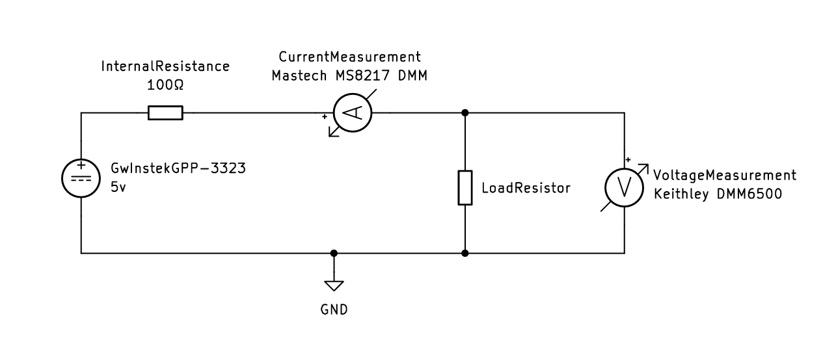

Figure 1. Maximum power transfer test circuit using the GW Instek GPP 3323 supply, 100 Ω nominal source resistance, Mastech MS8217 DMM, and interchangeable load resistance.

Each load resistor was connected to the source, and the load voltage and current were recorded. Measured load power was calculated from Equation (1). The theoretical power curve was calculated using Equation (2), and efficiency was calculated using Equation (3). MATLAB was used to generate a linear resistance plot, a logarithmic resistance plot, and an efficiency plot. The logarithmic sweep extended from 1 Ω to 100 MΩ so the maximum power condition and high resistance behavior could be viewed on the same graph.
$P_{L} = V_{o} I_{L}$
$P_{L} = \frac{{V_{TH}}^{2} R_{L}}{{\left(R_{TH} + R_{L}\right)}^{2}}$
$η = \frac{R_{L}}{R_{TH} + R_{L}} × 100\%$

Experiment 13 used the GW Instek GPP 3323 supply at 15 V and a Keithley DMM6500. The original circuit used nominal resistor values of 1 kΩ, 2.2 kΩ, 470 Ω, and 3.3 kΩ. The recorded measured values were approximately 0.981 kΩ, 2.18 kΩ, 461.2 Ω, and 3.26 kΩ. The calculated Thevenin resistance, Thevenin voltage, and loaded output voltage were determined before the circuit was built. Figure 2 will show the original circuit.

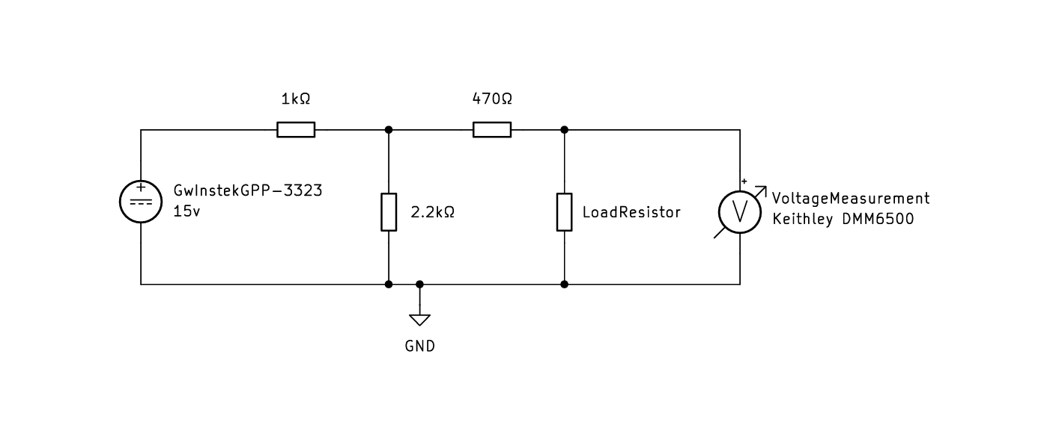

Figure 2. Original Thevenin theorem circuit using the GW Instek GPP 3323 supply, Keithley DMM6500, and nominal 1 kΩ, 2.2 kΩ, 470 Ω, and 3.3 kΩ resistors.

$R_{TH} = 470 Ω + \left(1 kΩ ∥ 2.2 kΩ\right) = 1157.5 Ω$
$V_{TH} = 15 V \frac{2.2 kΩ}{1 kΩ + 2.2 kΩ} = 10.31 V$
$V_{o} = V_{TH} \frac{R_{L}}{R_{TH} + R_{L}}$

The no load output voltage was measured first. The 3.3 kΩ load was then connected and the loaded output voltage was measured. To measure RTH, the supply was disconnected and replaced by a short circuit as directed in the laboratory procedure [1]. A physical Thevenin equivalent was then constructed using a nominal 1.15 kΩ resistance network made from a 1 kΩ resistor, a 100 Ω series resistor, and two 100 Ω resistors in parallel. The individual measured values used in this network were approximately 985.1 Ω, 97 Ω, 98 Ω, and 95 Ω. The equivalent source was adjusted to the measured VTH value, the same 3.3 kΩ load was connected, and the output voltage was measured. Figure 3 will show the constructed equivalent circuit.

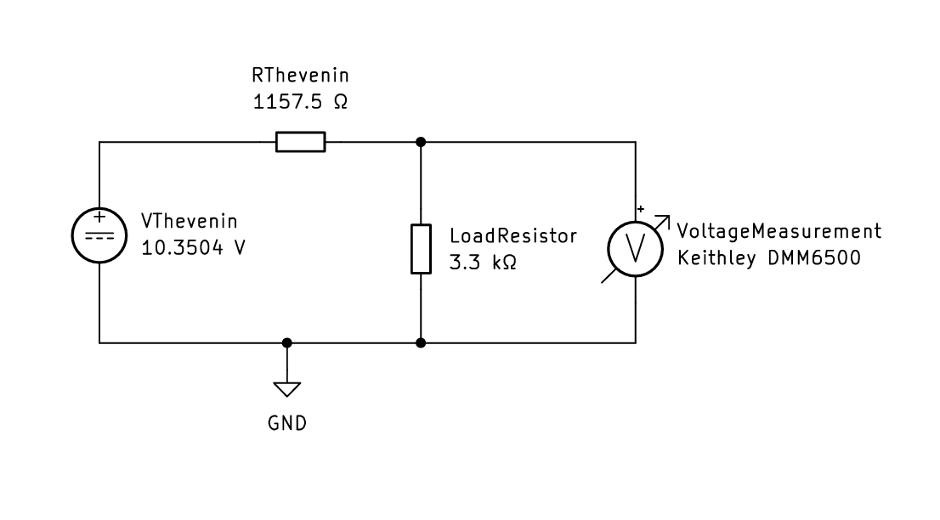

Figure 3. Constructed Thevenin equivalent using a 10.3504 V source, nominal 1.15 kΩ equivalent resistance network, 3.3 kΩ load, and Keithley DMM6500.

Results
Table 1 summarizes the Experiment 8 measurements and calculated load power. Of the tested resistors, the 266.7 Ω load produced the greatest measured power at 46.8 mW. The 9.61 kΩ load produced the highest measured load voltage at 4.9 V.

Table 1. Experiment 8 measured load data.
Nominal RL | Measured RL | VO (V) | IL (mA) | PL (mW)
270 Ω | 266.7 Ω | 3.6 | 13.0 | 46.80
470 Ω | 465 Ω | 4.1 | 8.9 | 36.49
1 kΩ | 985 Ω | 4.5 | 4.0 | 18.00
2.2 kΩ | 2.196 kΩ | 4.7 | 2.18 | 10.25
4.7 kΩ | 4.56 kΩ | 4.8 | 1.05 | 5.04
10 kΩ | 9.61 kΩ | 4.9 | 0.49 | 2.40

Figure 4 compares measured load power with the theoretical power curve over the lower resistance range. The theoretical curve reaches 62.5 mW at 100 Ω, which is the maximum power condition for the 5 V source and 100 Ω internal resistance.

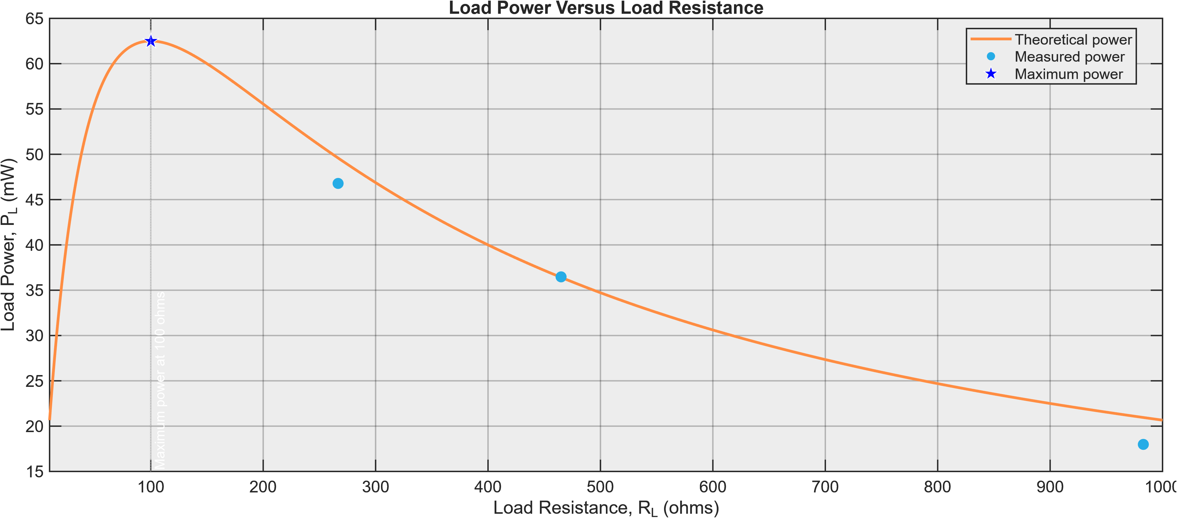

Figure 4. Load power as a function of load resistance on linear axes. The theoretical maximum occurs at RL = 100 Ω.

Figure 5 extends the resistance range logarithmically. It shows that load power decreases toward zero when the load is either much smaller or much larger than the source resistance.

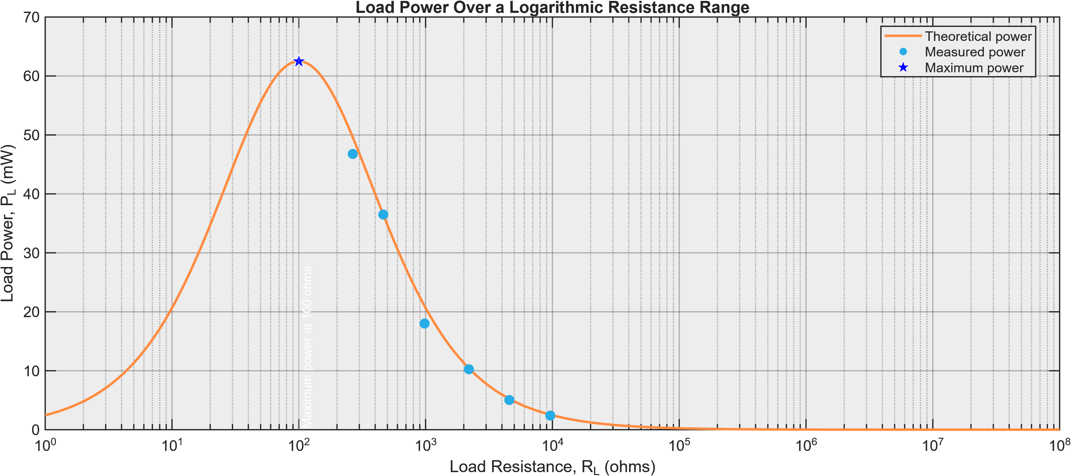
Figure 5. Load power over a logarithmic resistance range. The theoretical peak occurs at RL = RTH = 100 Ω.
Figure 6 shows the corresponding transfer efficiency. Efficiency is 50 percent at the maximum power condition and approaches 100 percent as the load resistance becomes much larger than the source resistance.

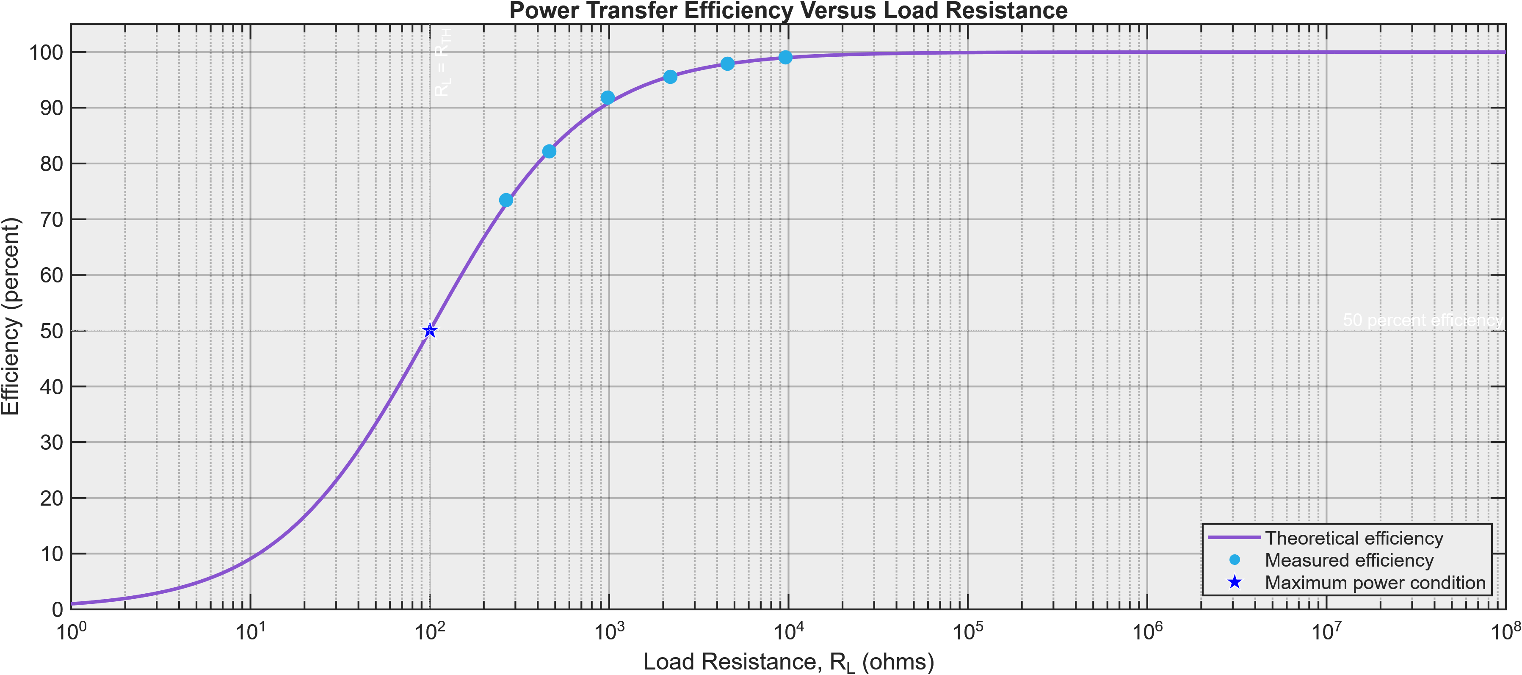
Figure 6. Power transfer efficiency as a function of load resistance. The RL = RTH condition gives 50 percent efficiency.

Table 2 compares the Experiment 13 calculations with the measured circuit values. The calculated and measured Thevenin quantities agreed within approximately 1.5 percent. The constructed equivalent circuit also reproduced the loaded output voltage closely.
Table 2. Experiment 13 calculated and measured results.
Quantity | Calculated or reference | Measured | Difference
VTH | 10.31 V | 10.3504 V | 0.39 percent
RTH | 1.1575 kΩ | 1.14087 kΩ | 1.44 percent
VO with 3.3 kΩ load | 7.632 V | 7.688 V | 0.73 percent
Equivalent circuit VO | 7.688 V original circuit | 7.7015 V equivalent | 0.18 percent

Discussion
The Experiment 8 results followed the expected maximum power transfer relationship. The theoretical maximum occurred at 100 Ω because the assumed source resistance was 100 Ω. A 100 Ω load was not included in the measured load set, so the 266.7 Ω resistor, which was the closest tested value to 100 Ω, produced the greatest measured power. As load resistance increased beyond this value, the load voltage moved closer to the 5 V source voltage, but current and load power decreased.
The logarithmic power plot makes the maximum power condition more apparent than the measured data alone because it includes resistance values on both sides of 100 Ω. The efficiency plot also shows why maximum power and maximum efficiency are different objectives. At RL = RTH, half of the source power is dissipated in the internal resistance. Larger load resistance improves efficiency because source current decreases, but the delivered load power also becomes smaller. The measured points generally followed the theoretical curve. Differences were consistent with resistor tolerance, instrument resolution, and rounding of the recorded voltage and current values. The 1 kΩ measurement showed the largest visible departure from the theoretical curve.
Experiment 13 provided close agreement between calculated and measured values. The measured VTH differed from the calculated value by 0.39 percent, the measured RTH differed by 1.44 percent, and the loaded output voltage differed by 0.73 percent. The nominal 1.15 kΩ resistor network used for the physical equivalent was within 2 percent of both the calculated and measured RTH values. When the equivalent circuit was loaded, its 7.7015 V output differed from the original circuit measurement of 7.688 V by only 0.18 percent.
These results demonstrate the practical value of Thevenin reduction. The original four resistor network and the simpler equivalent source produced nearly the same terminal behavior for the same load. Remaining differences can be attributed primarily to actual resistor values, supply setting accuracy, meter uncertainty, and connection resistance.

Questions

Experiment 8
1. A 50 Ω generator is connected to a 75 Ω load. Is maximum power transferred to the load?
No. Maximum power transfer occurs when the load resistance equals the generator internal resistance. A 50 Ω generator therefore requires a 50 Ω load for maximum power transfer.
2. If efficiency is the ratio of output power to total power produced by the power supply, which resistor in the experiment produced the best efficiency?
The 10 kΩ nominal load produced the best efficiency. Using the measured 9.61 kΩ value and a 100 Ω source resistance gives approximately 99 percent efficiency. This condition does not produce maximum load power.
3. What happens to the power dissipated by the internal resistance?
Internal power is $P_{internal} = I^{2}R_{TH}$. As load resistance increases, circuit current decreases and internal power decreases. At maximum power transfer, RL = RTH, so the load and internal resistance dissipate equal power.

Experiment 13
1. Referring to the Thevenin equivalent circuit, what load resistance would produce maximum output power?
Maximum output power occurs when RL = RTH. For this circuit, the required load is approximately 1.15 kΩ, using the calculated 1.1575 kΩ value or the measured 1.14087 kΩ value.
2. A generator with an internal resistance of 75 Ω has an output voltage of 15 V. A 1 kΩ potentiometer is connected across the output to vary the output. How does the Thevenin resistance change as the potentiometer is varied from zero to maximum output voltage?
With the source turned off, the resistance seen at the potentiometer wiper is the lower potentiometer section in parallel with the upper section plus 75 Ω. The Thevenin resistance is 0 Ω at zero output, rises to a maximum of about 269 Ω near the middle of the adjustment, and then falls to about 69.8 Ω at maximum output.
3. What is the ideal output resistance of a voltage source?
The ideal output resistance of a voltage source is 0 Ω.

Conclusions
Both experiment objectives were met. Experiment 8 showed that maximum load power occurs when load resistance equals source resistance. The theoretical maximum for the 5 V, 100 Ω source was 62.5 mW at a 100 Ω load. The measured resistor set did not include 100 Ω, so the 266.7 Ω load produced the greatest measured power at 46.8 mW. The results also showed that efficiency increases as load resistance increases, even though load power decreases after the maximum power point.
Experiment 13 verified Thevenin's theorem by showing close agreement between calculated values, direct measurements, and the constructed equivalent circuit. The equivalent circuit output differed from the original loaded circuit by only 0.18 percent. A useful improvement would be to include additional load values near 100 Ω in Experiment 8 and record current with greater precision so the measured power curve can be compared more directly with the theoretical maximum.

References
[1] EECE 225L Laboratory Manual, “Experiment 8: Maximum Power Transfer” and “Experiment 13: Thevenin's Theorem,” course handout.
[2] OpenAI, ChatGPT, response to author prompts for report drafting, organization, and proofreading. OpenAI [Online]. Available: https://chat.openai.com/. Accessed September 24, 2026.

Acknowledgments
OpenAI ChatGPT Astra was used to assist with report drafting, organization, and proofreading [2].

