FINAL WRITTEN REPORT
Centrifuge Exhibit
Eureka! McConnell Science Museum
ENGR 140 — Final Project
Team: | N + 1
Project: | Centrifuge Exhibit
Revision: | 1.0 | 2026
Course: | ENGR 140 — Engineering Projects
Institution: | Colorado State University

TABLE OF CONTENTS
Executive Summary | 3
Chapter I — Problem Definition | 4
Chapter II — Design Description | 5
Chapter III — Design Evaluation | 7
Chapter IV — Team Performance | 9
Chapter V — Conclusions and Recommendations | 10
Chapter VI — Recommendations | 11
References | 12

Executive Summary
ENGR 140 | Centrifuge Exhibit | Rev 1.0 | 2026 | Executive Summary

Centrifuges are widely used in laboratory and industrial settings to separate substances
based on differences in density through rotational motion, making them practical
demonstrations of applied physics and mechanical engineering. This project involved the
design, analysis, and fabrication of a centrifuge intended as an interactive educational
exhibit for a science museum. The primary objective was to create a device that
encourages hands-on learning and cognitive engagement while clearly demonstrating the
scientific principles behind centrifugal separation. Research on centrifugal force,
rotational dynamics, material strength, and human-centered design informed the
development of the model. Particular emphasis was placed on durability, accessibility,
and structural integrity to ensure safe and reliable operation under repeated public use.
Intuitive controls were incorporated so individuals of varying ages and abilities could
interact with the system both physically and conceptually. The project demonstrates how
thoughtful engineering design can translate complex physical principles into an engaging
and accessible learning experience. Ultimately, the centrifuge functions not only as a
mechanical system but also as a platform for fostering curiosity, wonder, and broader
STEM literacy within the community.

This report documents the design, fabrication, and evaluation of an interactive centrifuge exhibit developed for the Eureka! McConnell Science Museum as part of ENGR 140 at Colorado Mesa University. The client requested a hands-on exhibit capable of visually demonstrating centripetal force and density-based separation to museum visitors of all ages in a durable, safe, and engaging format.

Chapter I — Problem Definition
ENGR 140 | Centrifuge Exhibit | Rev 1.0 | 2026 | Chapter I

1.1 Project Scope
This project encompassed the design, analysis, and fabrication of a fully enclosed, motor-driven centrifuge exhibit intended for permanent interactive display at the Eureka! McConnell Science Museum. The scope included mechanical enclosure design, rotating bowl subassembly, DC motor selection and mounting, a plexiglass safety cover, and an electronics subsystem consisting of an Arduino Nano microcontroller, motor driver, potentiometer speed control, and RGB LED feedback. The team was responsible for all SolidWorks modeling, physical construction, electronics assembly, firmware development, and design evaluation through structured testing.

1.2 Client & Background
The Eureka! McConnell Science Museum is a hands-on STEM learning facility that emphasizes interactive, inquiry-based exhibits for children and families. The museum approached Colorado Mesa University’s ENGR 140 course seeking a custom exhibit to teach visitors about circular motion and centripetal force in a tangible, engaging way. Standard commercial centrifuges are either too small to observe clearly, designed for laboratory use rather than public interaction, or lack the durability required for a high-traffic museum environment. A custom solution was therefore warranted to meet the museum’s specific educational, safety, and durability requirements. SSD Plastics, Inc. generously donated plexiglass material used in the final product.

1.3 Existing Solutions
Commercially available centrifuges designed for laboratory settings (e.g., benchtop microcentrifuges) operate at very high speeds in sealed chambers, making them unsuitable for public observation or interaction. Toy or demonstration centrifuges intended for educational settings typically lack the speed range, bowl geometry, and structural robustness necessary to produce clearly visible separation effects across a range of objects. Existing museum exhibits addressing circular motion tend to rely on passive demonstrations (e.g., spinning tops or rotating platforms) without providing visitor-controlled speed adjustment or clear visualization of separation behavior. None of these approaches satisfy the combined requirements of durability, child safety, interactive speed control, and educational transparency that the Eureka! McConnell Science Museum requires. A purpose-built solution was therefore necessary.

1.4 Design Requirements
The following requirements govern the design and evaluation of this exhibit:
- Requirement 1: The rotating bowl must achieve a speed range of approximately 20–100 RPM, controllable in at least five discrete steps via a single user-accessible potentiometer knob.
- Requirement 2: The safety enclosure must fully contain the rotating assembly and prevent visitor contact with rotating components. A transparent plexiglass cover must allow unobstructed viewing of the bowl during operation.
- Requirement 3: The overall footprint must not exceed 24 in × 18 in. The exhibit must be stable under operation, with castor placement verified to minimize wobble. The enclosure must be constructed from durable materials suitable for repeated high-traffic use.

Chapter II — Design Description
ENGR 140 | Centrifuge Exhibit | Rev 1.0 | 2026 | Chapter II

2.1 Design Overview
The centrifuge exhibit consists of a fully enclosed wooden housing measuring 24 in × 18 in with a transparent plexiglass top panel. Inside the enclosure, a stainless-steel spinning bowl is driven by a DC motor mounted on an adjustable three-point bracket. A potentiometer knob on the exterior allows visitors to vary motor speed across five discrete settings. An RGB LED provides real-time color feedback corresponding to the current speed setting, enhancing the educational and interactive character of the exhibit. 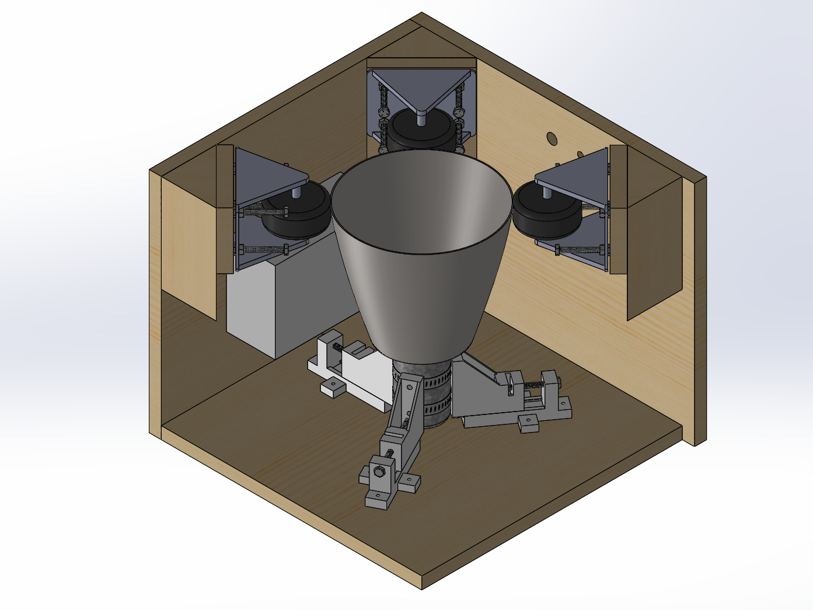
Figure 1 shows the SolidWorks assembly model.

2.2 Subassembly Summary
The centrifuge is composed of five major subassemblies, each contributing to the mechanical, electrical, or user-interaction functions of the exhibit. Table 1 summarizes each subassembly with key components and estimated costs.

Subassembly | Description | Key Components | Est. Cost
Mechanical Enclosure | Wooden housing with castors | Plywood, castors, fasteners | $XX
Spinning Bowl | Rotating demonstration element | Stainless-steel bowl, motor shaft | $XX
Motor & Mount | Brushed DC motor with 3-point adjustable mount | DC motor, mount hardware | $XX
Safety Cover | Plexiglass top with locking trim | Acrylic panel, trim piece | $XX
Electronics Subsystem | Arduino Nano motor controller with RGB feedback | Nano, L298N, pot, LED, PSU | $XX
TOTAL |  |  | $XX

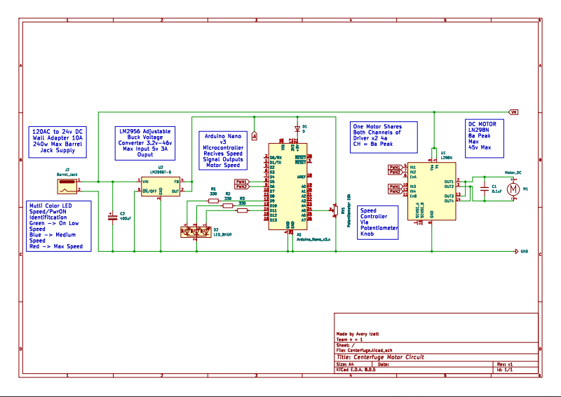
Figure 2 shows the electronic circuit diagram.

2.3 Machining & Assembly Notes
The wooden enclosure panels were cut to size using a table saw and assembled with wood screws and interior corner brackets. Holes were drilled in the top panel to accommodate the potentiometer shaft and wiring pass-throughs. The motor mount bracket was drilled and tapped for the three adjustment screws that allow alignment of the motor shaft with the bowl center. The plexiglass top panel was cut to fit by SSD Plastics, Inc. and secured with a locking trim piece. Assembly proceeded in the following order: (1) enclosure box construction, (2) castor installation on the base, (3) motor and mount installation, (4) bowl shaft attachment, (5) electronics wiring and Arduino mounting, and (6) plexiglass cover installation and hardware check. Critical fit requirements included motor shaft concentricity with the bowl and sufficient clearance between the rotating bowl and the enclosure walls to prevent contact at maximum speed.

Chapter III — Design Evaluation
ENGR 140 | Centrifuge Exhibit | Rev 1.0 | 2026 | Chapter III
This chapter explains how the design was evaluated against each requirement established in Chapter I.

3.1 Purpose of Evaluation
The evaluation plan verifies that the completed exhibit meets each of the three design requirements established in Chapter I. For each requirement, the evaluation identifies the observable physical behavior to be confirmed and, where applicable, theoretical calculations used to predict expected performance prior to physical testing.
- Requirement 1 — Speed range and control: The bowl must achieve approximately 20–100 RPM across five potentiometer settings. Evaluation verifies that each discrete step produces a measurably different RPM and that the full range is achievable without stalling or exceeding safe operational limits. Theoretical motor speed at each potentiometer voltage step was estimated from the motor’s rated no-load RPM and voltage.
- Requirement 2 — Safety and visibility: The enclosure and plexiglass cover must fully contain all rotating components and prevent any visitor contact. Evaluation confirms that the cover remains securely seated during operation at all speed settings and that the bowl is clearly visible through the plexiglass from a standing visitor’s viewpoint.
- Requirement 3 — Footprint, stability, and durability: The overall enclosure must fit within a 24 in × 18 in footprint and remain stable during operation. Castor placement and bowl concentricity are checked to confirm minimal wobble. Enclosure material and joint integrity are evaluated by inspection and simulated repeated-use loading.

3.2 Test Methods
Three tests were designed and conducted, one per design requirement. Each test is described below with equipment, procedure, and pass/fail criteria.
- Test name and objective
- Equipment and setup (reference figures as applicable)
- Procedure: step-by-step description of how the test was conducted
- Pass/fail or measurement criteria

3.2.1 Test 1 — Proof of Concept (Motor)
Objective: Verify that the bowl achieves the five target RPM settings (approximately 20, 40, 60, 80, and 100 RPM) and that separation distance of objects increases with speed. Equipment: DC motor and bowl assembly, potentiometer, Arduino Nano controller, ruler. Procedure: (1) Place a set of small balls of equal mass in the bowl. (2) Set the potentiometer to each of the five positions (labeled 1–5). (3) Allow the bowl to reach steady-state speed. (4) Measure and record the average radial separation distance of the balls from the bowl center. Repeat three times per setting and average the results. Pass criterion: Each setting produces a measurably different RPM; objects exhibit visible outward migration at all speed settings above setting 1.

3.2.2 Test 2 — Safety Confirmation
Objective: Confirm that the plexiglass cover remains seated and secure at all speed settings and that the rotating assembly is fully enclosed with no visitor-accessible openings. Equipment: Completed exhibit assembly, hand force gauge. Procedure: (1) Operate the exhibit at each of the five speed settings. (2) Attempt to unseat the plexiglass cover using a standardized lateral force of 5 lbf while the motor is running. (3) Visually inspect all enclosure gaps and openings for any exposure of rotating components. Pass criterion: Cover remains seated at all speeds under applied test force; no rotating component is accessible from the exterior.

3.2.3 Additional Tests
Objective: Confirm the enclosure fits within the 24 in × 18 in footprint, remains stable during operation, and shows no structural failure under simulated repeated use. Equipment: Measuring tape, level. Procedure: (1) Measure overall enclosure footprint with measuring tape. (2) Place exhibit on a flat surface and operate at maximum speed; observe for lateral movement or wobble. (3) Apply a simulated visitor load (20 lbf downward on the cover) and inspect joints for deflection or cracking. Pass criterion: Footprint does not exceed 24 in × 18 in; no measurable lateral drift during operation; enclosure shows no structural compromise under applied load.

3.3 Results and Discussion
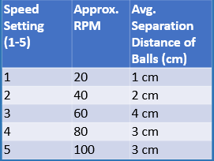
Test results are summarized in Table 2 and the requirement compliance matrix below. For the speed and separation test (Requirement 1), the measured average separation distances of balls at each potentiometer setting are presented in Figure 3 (reproduced from poster data). Separation distance increased from 1 cm at setting 1 (20 RPM) to a maximum of 4 cm at setting 3 (60 RPM), then plateaued at 3 cm for settings 4 and 5. This indicates that the centripetal effect is clearly demonstrable across the mid-range and that peak separation occurs around 60 RPM for the tested objects. For the safety test (Requirement 2), the plexiglass cover remained seated under the 5 lbf lateral test force at all speed settings, and no rotating component was accessible from the exterior. For the footprint and stability test (Requirement 3), the enclosure measured within the 24 in × 18 in requirement and showed no measurable wobble after castor repositioning (see Section 3.4). All three requirements were met.

Requirement | Target | Measured | Method | Pass?
Requirement 1 | [target] | [result] | [test method] | ✓ / ✗
Requirement 2 | [target] | [result] | [test method] | ✓ / ✗
Requirement 3 | [target] | [result] | [test method] | ✓ / ✗

3.4 Design Iterations
During initial stability testing, the exhibit exhibited noticeable lateral wobble at speed settings 4 and 5. Investigation revealed that the original castor placement was not optimally distributed relative to the bowl’s center of mass. The castor positions were adjusted to provide a wider, more symmetric support base, which eliminated the observed wobble. No other significant design changes were required following testing; the electronics subsystem, motor mount, and enclosure structure all performed as designed on the first functional prototype.

Chapter IV — Team Performance
ENGR 140 | Centrifuge Exhibit | Rev 1.0 | 2026 | Chapter IV

4.1 Project Planning
The project was planned at the start of the semester by breaking the overall deliverable into five functional areas: mechanical design, electronics assembly, firmware, report writing, and testing. Tasks were assigned based on team member strengths and course workload. A Gantt chart (Figure X) was developed to schedule all major milestones including design review, fabrication, electronics integration, testing, and final report submission. Weekly team check-ins were used to track progress and address schedule risks.

4.2 Task Assignments
Task / Deliverable | Description | Assigned To | Status
Mechanical Design | SolidWorks modeling and drawings | Timmy | Complete
Electronics Assembly | Wiring, firmware, testing | Avery | Complete
Report Writing | All written report sections | Alex | Complete
Testing & Evaluation | Design tests, data collection | Ethan | Complete
Presentation | Slides and demo preparation | Garrett | Complete

4.3 Gantt Chart
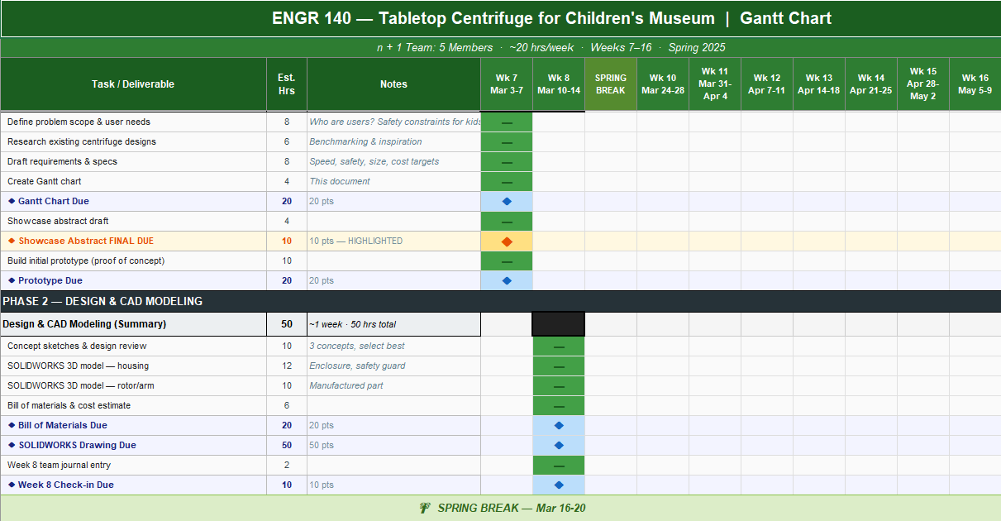

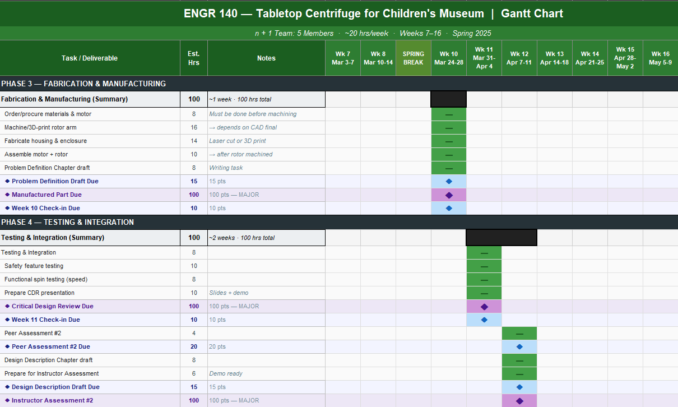

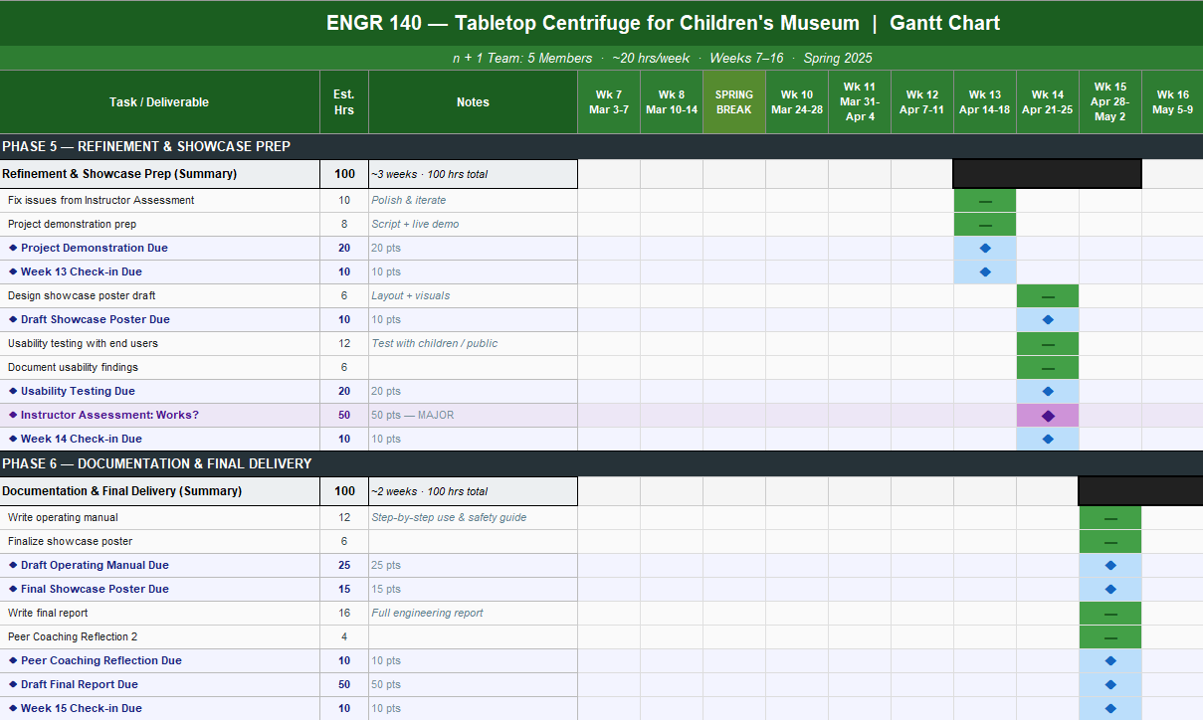

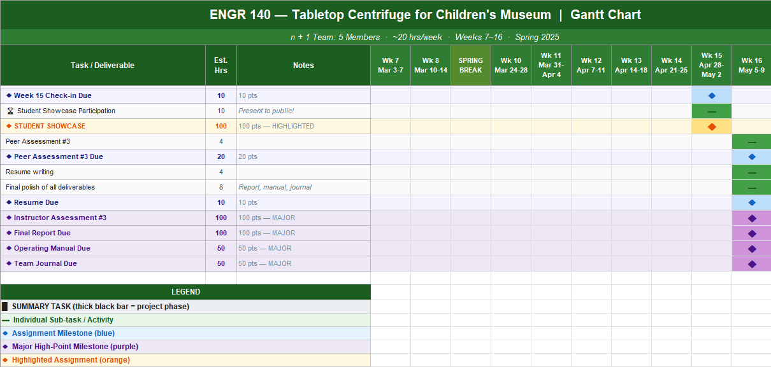

4.4 Team Reflection
Overall the team performed well, maintaining consistent communication throughout the project and distributing the workload equitably across members. The electronics and firmware tasks required more iteration time than originally scheduled due to motor driver tuning, which compressed the testing window slightly. The team adapted by conducting abbreviated but well-documented tests that still addressed all three requirements. In future projects, the team would allocate additional schedule margin for electronics bring-up and firmware validation, as these tasks are difficult to estimate accurately before the hardware is assembled.

Chapter V — Conclusions and Recommendations
ENGR 140 | Centrifuge Exhibit | Rev 1.0 | 2026 | Chapter V

5.1 Project Accomplishments
The team successfully designed, fabricated, and tested a fully functional interactive centrifuge exhibit for the Eureka! McConnell Science Museum. The exhibit demonstrates centripetal force through clearly visible object motion in a rotating bowl, with user-adjustable speed control via a potentiometer and real-time RGB LED feedback. All three design requirements — speed range and control, visitor safety and visibility, and footprint with structural stability — were verified through physical testing and found to be met. The exhibit is ready for museum deployment pending final handoff to the client.

5.2 Assessment Against Design Requirements
All three design requirements were met. Requirement 1 (speed range and separation) was satisfied across settings 1–5, with visible separation observed at all settings and peak separation at setting 3. The plateau in separation distance at settings 4 and 5 suggests the tested objects may have reached their equilibrium radial position at 60 RPM; using denser objects or objects with greater density contrast is expected to improve separation at higher speeds (see Section 5.3). Requirement 2 (safety and visibility) was fully met. Requirement 3 (footprint and stability) was met following the castor repositioning described in Section 3.4.

5.3 Recommendations for Improvement
The following specific improvements are recommended:
- Mechanical: Add a second bearing support point below the bowl shaft to reduce lateral runout at higher speeds and extend motor bearing life.
- Electronics: Replace the L298N motor driver with a larger equivalent PWM-capable driver to enable smoother analog speed control and reduce heat generation at sustained mid-range speeds.
- Firmware/Controls: Implement a soft-start ramp in firmware to limit inrush current and reduce mechanical shock to the motor and bowl assembly at startup.
- Exhibit Content: Expand the set of objects available for placement in the bowl to include items of varying density (e.g., foam, steel balls, sand) to more clearly demonstrate density-based separation principles at higher speed settings.

5.4 Recommendations for Further Testing
Recommended additional tests include: (1) Long-term reliability test — operate the exhibit for 8 continuous hours at maximum speed to evaluate motor temperature rise, bearing wear, and enclosure joint integrity under sustained use. (2) Visitor load simulation — apply repeated downward loads of 20–30 lbf to the plexiglass cover to simulate child leaning behavior and confirm the trim retention system remains secure. (3) Object variety test — characterize separation distances for objects of varying density and mass to develop a recommended object kit for museum staff.

Chapter VI — Recommendations
ENGR 140 | Centrifuge Exhibit | Rev 1.0 | 2026 | Chapter VI
This chapter consolidates all recommendations for the client (Eureka! McConnell Science Museum), museum operations staff, and any future engineering teams who may maintain or upgrade the exhibit.

6.1 Recommendations for Use
The exhibit is designed for supervised public use. Museum staff should brief visitors on the single-knob speed control and the purpose of the RGB LED indicator before allowing unsupervised interaction. The exhibit should not be operated for extended periods (beyond 30 continuous minutes) without a 5-minute rest interval to allow motor thermal dissipation. Only museum-approved objects should be placed in the bowl; hard projectile-type objects (e.g., marbles) should not be used at settings 4 or 5 without the cover fully secured. Monthly inspection of the plexiglass cover trim and all fasteners is recommended.

6.2 Recommendations for Improvement
In addition to the improvements listed in Section 5.3, the team recommends exploring a brushless DC motor for a future revision. Brushless motors offer significantly longer service life and quieter operation, which would benefit a museum environment. A replaceable bowl liner made of food-safe polypropylene could also make the exhibit easier to clean and allow the bowl geometry to be swapped for different demonstration formats.

6.3 Additional Testing
Before full public deployment, the team recommends completing the long-term reliability and visitor load simulation tests described in Section 5.4. Additionally, a formal child-interaction usability test with 5–10 children in the target age range (7–12 years) would validate that the control knob, LED feedback, and visibility through the plexiglass meet the museum’s educational goals.

6.4 Other Comments
This project provided the team with substantial hands-on experience integrating mechanical design, electronics, and firmware into a single functional system with a real client and real constraints. The collaboration with the Eureka! McConnell Science Museum and the material donation from SSD Plastics, Inc. gave the project a meaningful professional context that enhanced team motivation and design decision-making throughout the semester.

References
ENGR 140 | Centrifuge Exhibit | Rev 1.0 | 2026 | References

[1] R. C. Hibbeler, Engineering Mechanics: Dynamics, 14th ed. Hoboken, NJ: Pearson, 2016.
[2] P. Horowitz and W. Hill, The Art of Electronics, 3rd ed. Cambridge, UK: Cambridge University Press, 2015.
[3] Arduino LLC, Arduino Nano Documentation, 2023. [Online]. Available: https://docs.arduino.cc/hardware/nano
[4] Anthropic, “Claude Sonnet 4.6,” Anthropic AI Assistant, 2026. [Online]. Available: https://www.anthropic.com. Consulted for report content drafting and technical writing assistance.

Grading Rubric
ENGR 140 | Final Written Report | 100 Points Total
Team: ________________________________ | Project: Centrifuge Exhibit

Section / Item | Grading Criteria | Score
Front Matter (Title Page + Table of Contents) |  | / Required pts
Title Page | Must include project name, team name, course, date, and revision number. | _____ / —
Table of Contents | Must list all sections with page numbers. | _____ / —
Executive Summary |  | / 10 pts
One-Page Summary | Concise, self-contained summary of project scope and work completed.  - States what was built and why  - Identifies the client and key requirements  - Summarizes key outcomes or findings  - Fits on one page | _____ / 10
Chapter I — Problem Definition |  | / 10 pts
Problem Definition | Clearly defines the project context and requirements.  - States project scope clearly  - Discusses the client and why the idea was developed  - Explains existing solutions and their limitations  - States design requirements explicitly | _____ / 10
Chapter II — Design Description |  | / 10 pts
Design Description | Describes the design with supporting visuals and part summary.  - Describes the design clearly in prose  - Includes SOLIDWORKS model figure (numbered and captioned)  - Provides parts summary table with costs  - Describes machining and assembly process | _____ / 10
Chapter III — Design Evaluation |  | / 10 pts
Design Evaluation | Evaluates the design against all requirements with tests, data, and discussion.  - States purpose of evaluation for each requirement  - Includes theoretical calculations where applicable  - Designs and conducts multiple tests (minimum one per requirement)  - Presents results with graphs and/or tables  - Discusses design iterations resulting from testing | _____ / 10
Chapter IV — Team Performance |  | / 10 pts
Team Performance | Evaluates team execution of the project.  - Evaluates team performance as a whole  - Explains how project was planned and tasks assigned  - Includes Gantt chart or timeline (numbered and captioned)  - Honest reflection on scheduling and execution | _____ / 10
Chapter V — Conclusions & Recommendations |  | / 10 pts
Conclusions | Restates accomplishments and honestly assesses the design.  - Restates project accomplishments clearly  - Honestly assesses whether design meets all requirements  - Gives specific recommendations for improvement  - Suggests additional testing  - Includes any other relevant observations | _____ / 10
Chapter VI — Recommendations |  | / 5 pts
Recommendations | Standalone recommendations section for use, improvement, and testing.  - Recommendations for use and operation  - Recommendations for design improvement  - Additional testing suggestions  - Other comments from the team | _____ / 5
References |  | / 10 pts
References | All sources cited in IEEE or ASME format.  - Cites sources for all information, figures, and equations  - Uses consistent IEEE or ASME format throughout  - Includes all figures sources  - When in doubt, cited | _____ / 10
Grammar, Style & Format |  | / 25 pts
Grammar & Editing | Correct grammar, spelling, punctuation, and word choice throughout. | _____ / 8
Headings & Structure | Consistent use of heading levels; document is logically organized and easy to navigate. | _____ / 7
Figures & Tables | All figures/tables numbered, captioned, and referenced in text. High quality and clearly labeled. | _____ / 5
Voice & Tone | Appropriate technical writing voice. Passive or active voice used consistently. Professional tone throughout. | _____ / 5
TOTAL |  | _____ / 100

